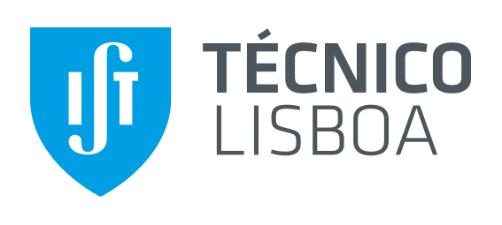

Instituto Superior Técnico

Network and Computer Security

Medical Records

Group 28 – Alameda

83531 |  | Miguel Belém
83567 |  | Tiago Gonçalves
83576 |  | Vítor Nunes

Problem
In today's world, data is considered the most valuable resource. In all branches where computer and information are used, there is one that requires special attention. Medical information are very sensitive and precise information that should be handled with special precautions.
Availability, data integrity and privacy are the most concern topics. Who need to be able to access the patient records? The doctors, all of them? At any time of day? Even if some doctor no longer works in a specific health house?
The dangerous situations become result of IT information threads, this could lead to:
- If for some reason, the patient it’s allergic to some medications and that information is omitted, then this could harm the patient.
- The more data that the health institution stores the more will be spend on infrastructure, backup and maintenance.

Requirements
The following security requirements were identified for the solution:
- Availability: the system must always be available;
- Access control: “Need to know basis”. Only those who really need to access information should be able to do it and should lost the access when that need disappears. It should also exists a change history that keeps tracking of patient data changes and tie them with author.
- Non-repudiation: Ensures that the change’s author effectively did that change.
- Data integrity: prevent the system from unauthorized changes / tampering.
- Replication: Decentralize the solution, by replicate the data through several machines. This also helps availability.

Proposed solution

Tool references

Work plan

 | Miguel | Tiago | Vítor
Oct. 15 – 21
Oct. 22 – 28
Oct. 29 – Nov. 4
Nov. 5 – 11
Nov. 12 – 18
Nov. 19 – 25
Nov. 26 – Dec. 2
Dec. 3 – 9
Dec. 10 – 22 (Deadline)

BS → Basic Solution
IS → Intermediate Solution
AS → Advanced Solution

